Lab Assignment-2



NAME: M Gyanada Chowdary

REG.NO: 21bce7727

COURSE: Computer Networks

SLOT: L21+22

TASK: CREATE A WAN USING A ROUTER AND TWO SWITCHES.

Router:

A router is a device that connects two or more packet-switched networks or subnetworks.

It serves two primary functions:

managing traffic between these networks by forwarding data packets to their intended IP addresses

and allowing multiple devices to use the same Internet connection.

Example: Mail Carrier

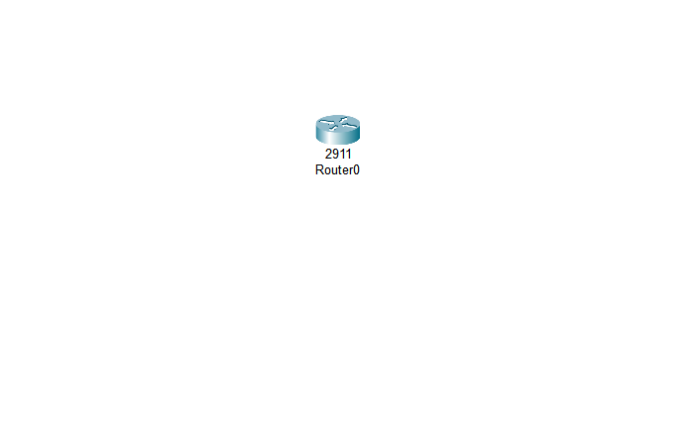

To create A WAN using a Router and Two switches

STEP 1: Create 2 LANs

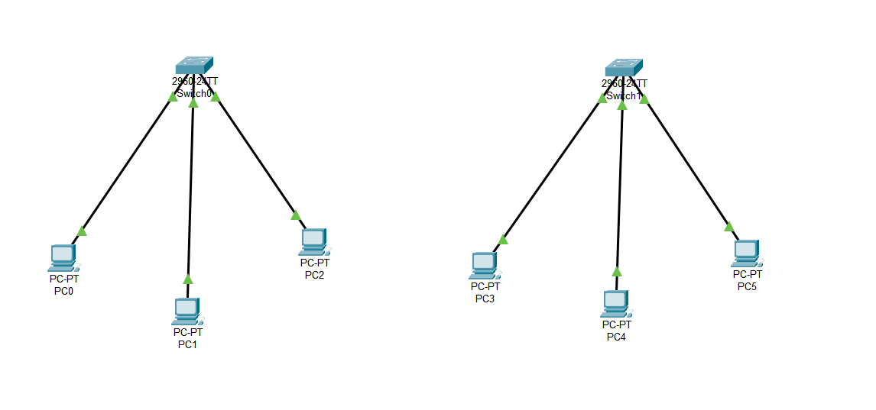

STEP 2: Give IP configuration for each PC for both LANs

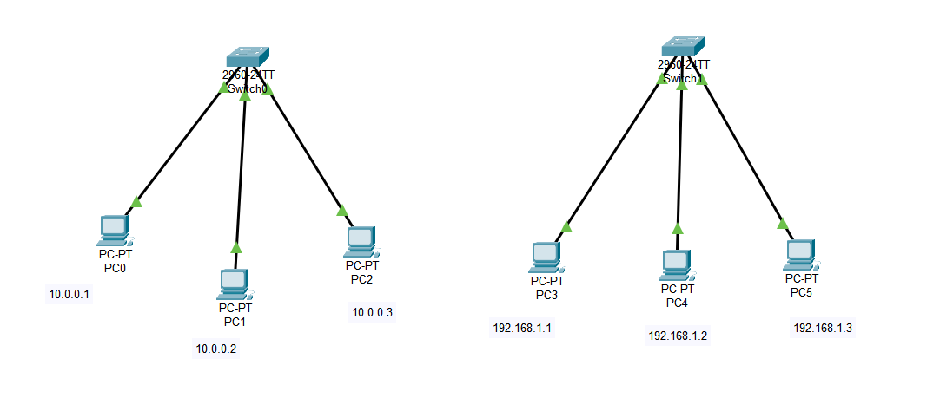

STEP 3: Connect the 2 LANs with the help of a Router.

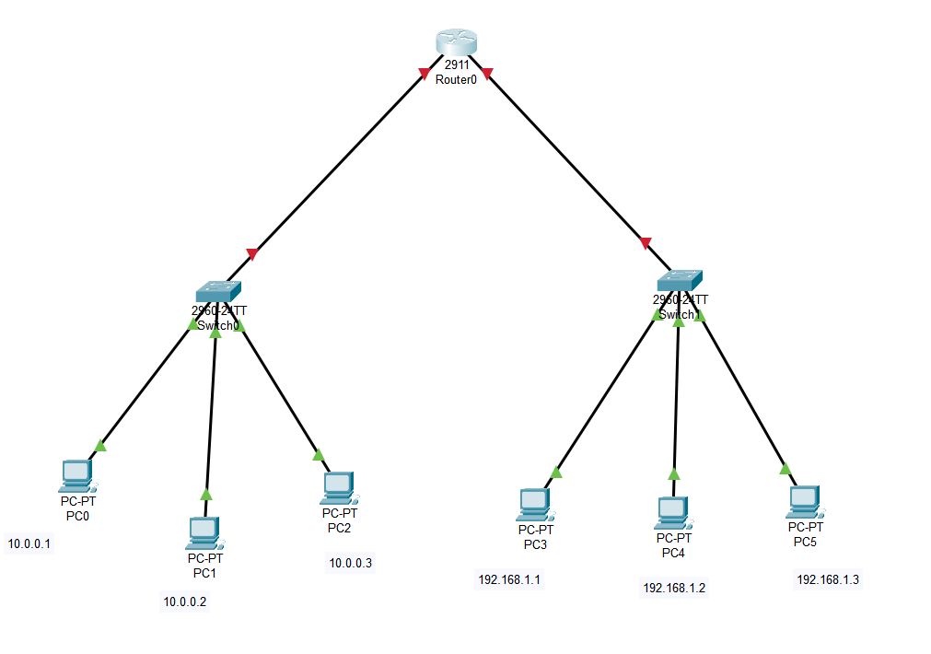

STEP 4: Router must be configured using CLI.

For interface 1:

Router>enable

Router#configure terminal

Enter configuration commands, one per line. End with CNTL/Z.

Router(config)#interface GigabitEthernet0/0

Router(config-if)#

Router(config-if)#no shutdown

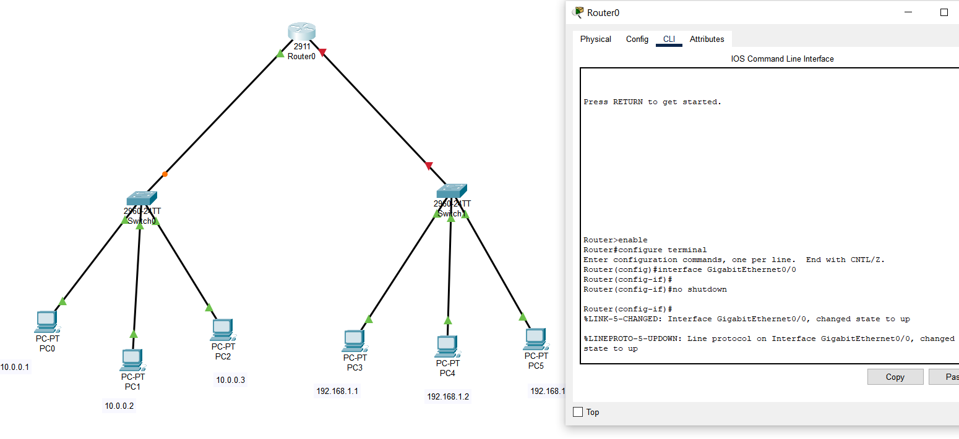

Follow the same process for interface 2. We have now configured the router by turning

on the port status using CLI.

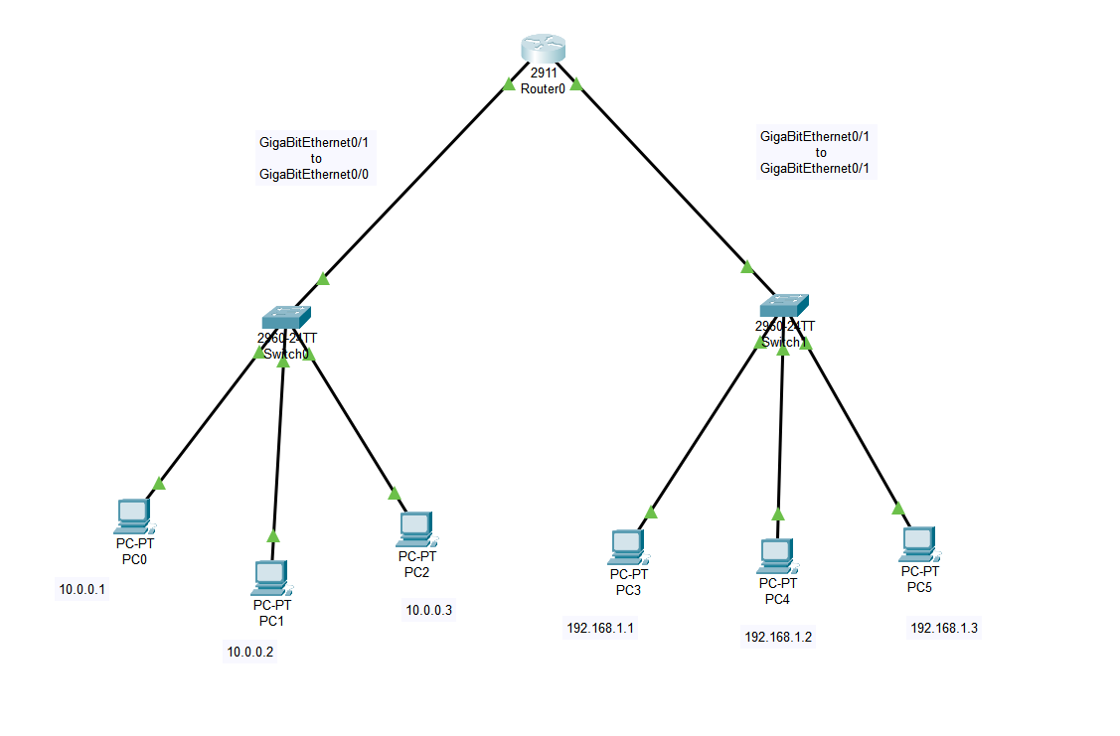

STEP 5: Give IP Addresses for the interfaces of router and set Default gateways to the Pcs

For GigabitEthernet0/0 – 10.0.0.4

For GigabitEthernet0/1 _ 192.168.1.4

For LAN 1 – Default Gateway = 10.0.0.4

For LAN 2 _ Default Gateway = 192.168.1.4

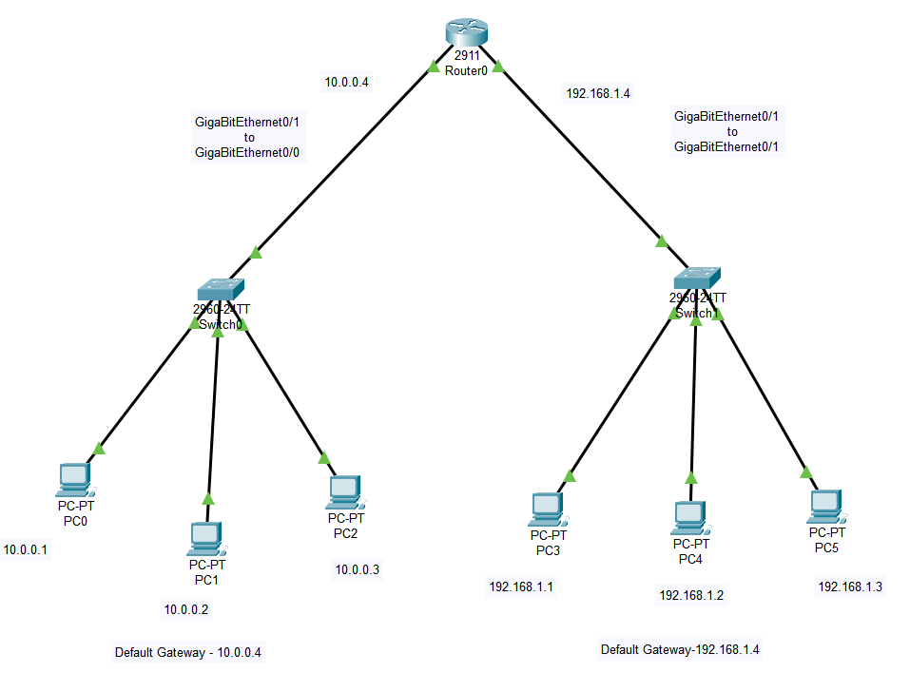

Step 6: Take a Simple PDU and Give source and Destination PC and check whether the

WAN is working.

Source – PC0(10.0.0.1)

Destination – PC4(192.168.1.2)

1)

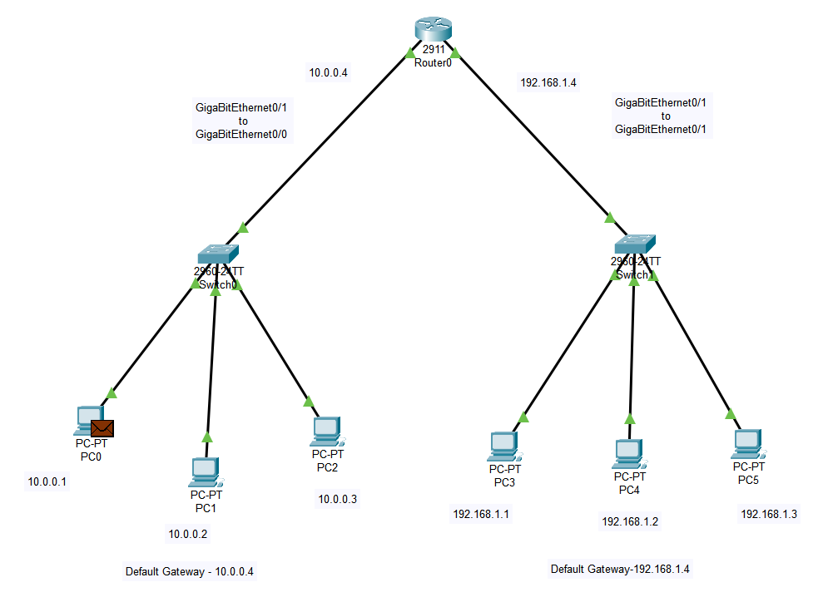

2)

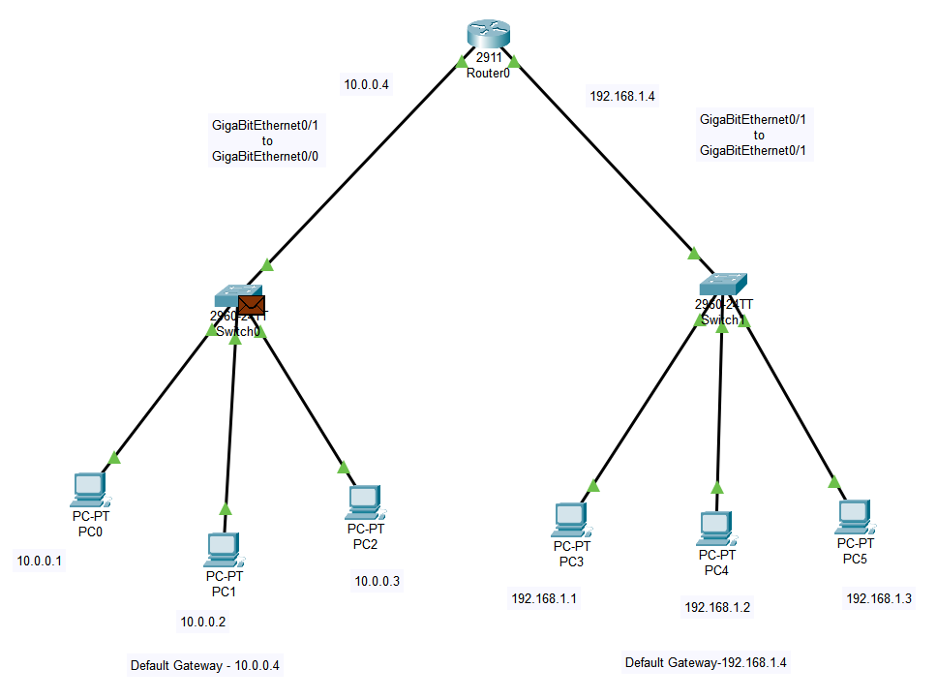

3)

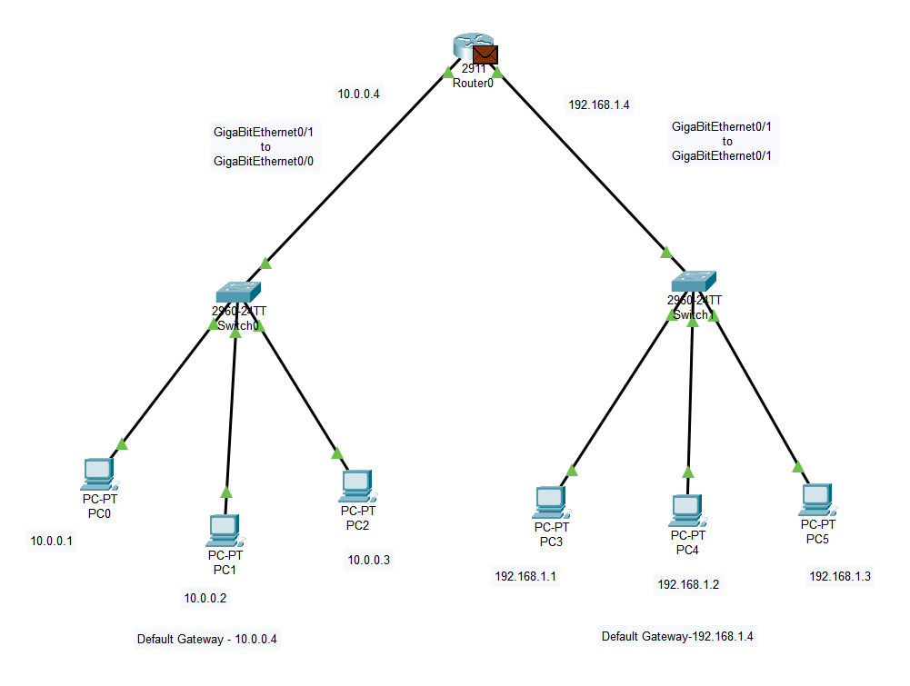

4)

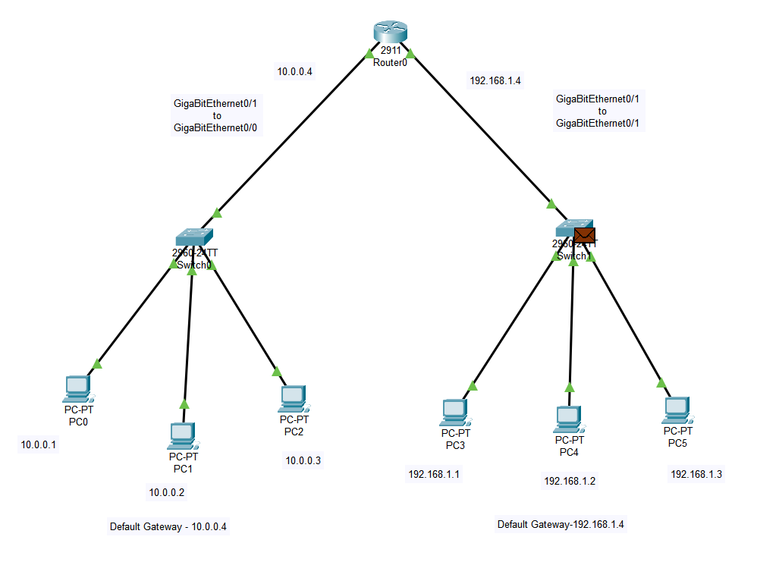

5)

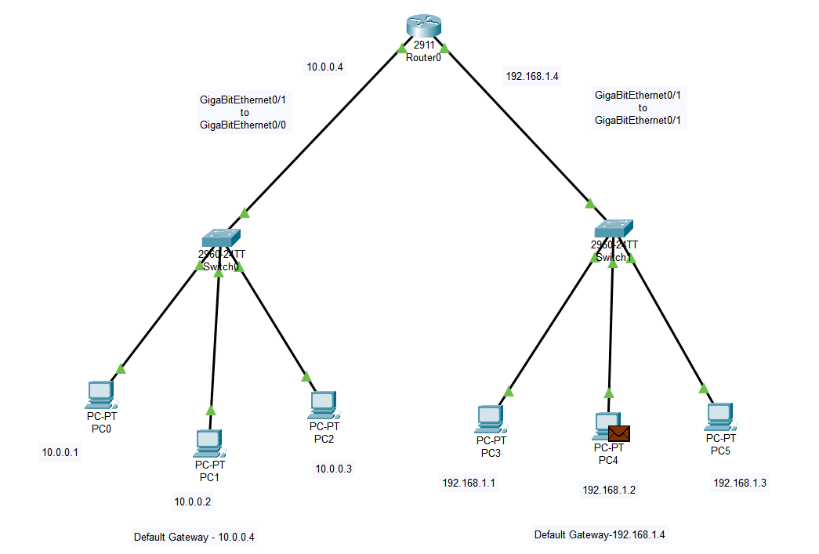

6)

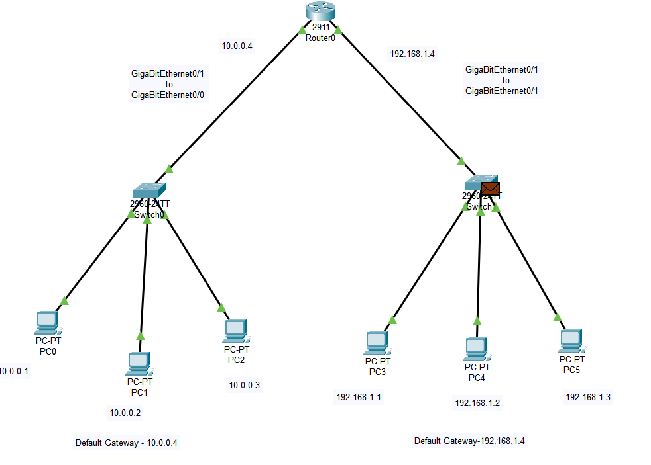

7)

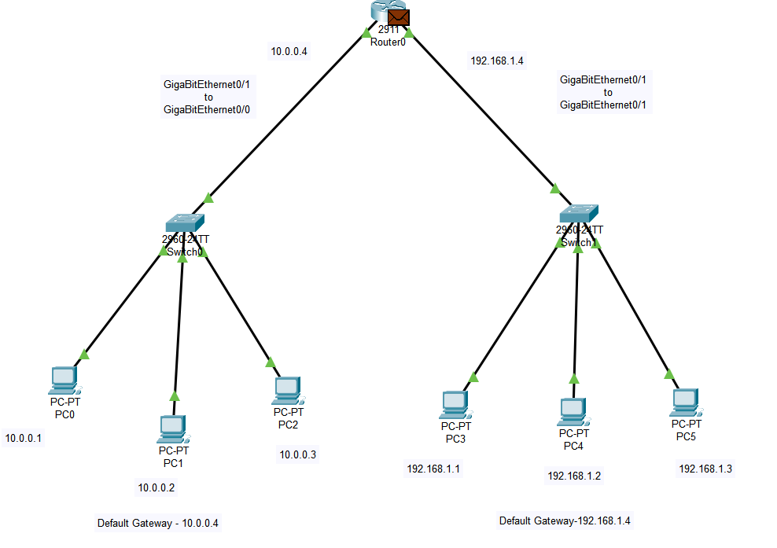

8)

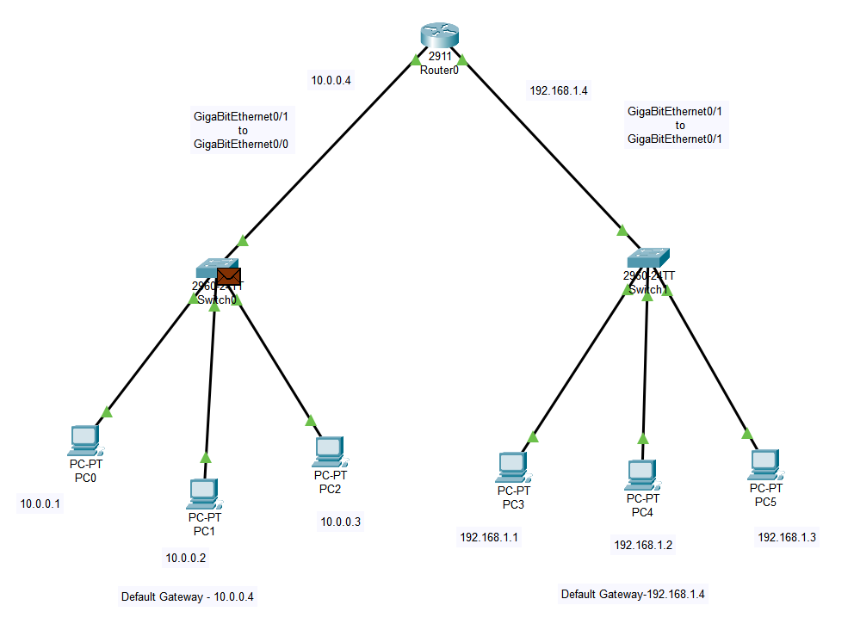

9)

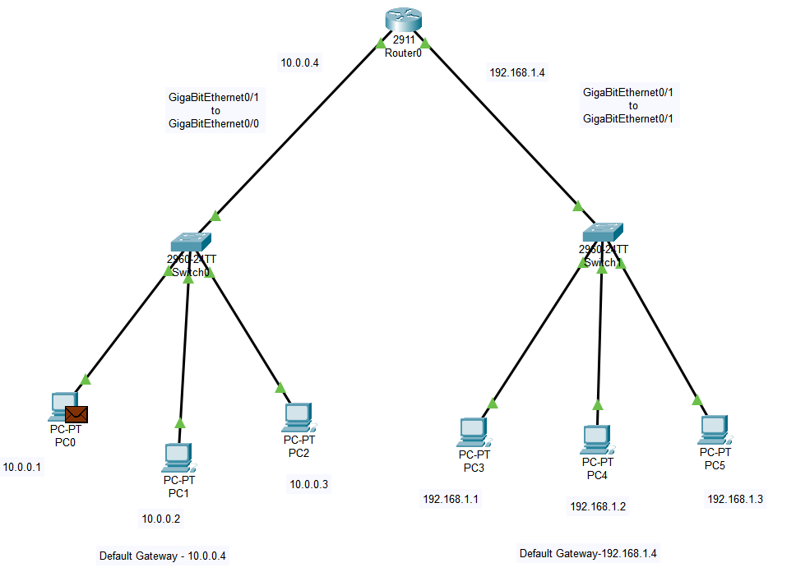

Final output:

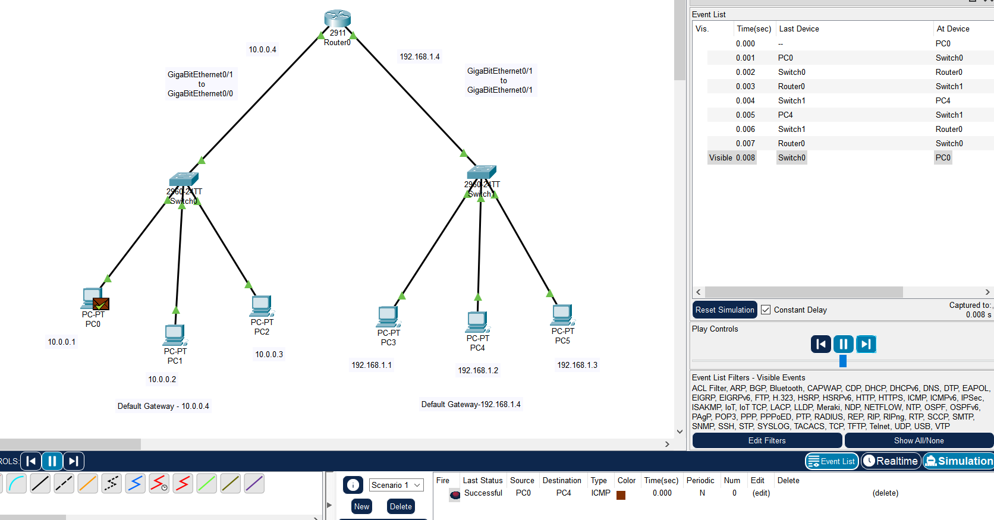

END